Project Description

Project Description
For this project, you will write a C++ application that solves a maze using an iterative, stack-based backtracking algorithm. The maze will be provided as a file containing a grid of zeros and ones, where zeros represent open paths and ones represent walls. Your program will read the file, store the maze in a suitable data structure (such as a vector of vectors), and then attempt to find a valid path from the entrance to the exit. If a path is found, the program will output the maze with the solution path identified. The output will display zeros for unused open cells, ones for walls, and a space character for the cells that are part of the path. Optionally, you may print the path in color using ANSI escape sequences.
This project is intended for learning purposes only, focusing on algorithm design and problem solving.

Goals

Goals
- To gain more practice with C++ programming.
- To learn how to implement a backtracking algorithm for solving mazes.
- To understand stack-based solutions to problems, reinforcing the connection between recursion and explicit use of stacks.
- To practice designing and implementing classes that encapsulate data and behavior, such as a Maze class responsible for solving a maze given its description and printing its solution when asked.

A Few Definitions

A Few Definitions
- A cell is a tuple consisting of a row and a column.
- A cell can either be a wall cell or a path cell.
- A maze is enclosed by wall cells except for two open cells, which serve as the start and the target cells.
- Two cells are adjacent if one is immediately above, immediately below, immediately to the right, or immediately to the left of the other. You can only connect adjacent cells that are path cells. Solving a maze means finding a path that connects the start cell to the target cell by moving only through adjacent path cells.
The following diagram demonstrates the notion of adjacency for a few selected cells. In this illustration, walls are replaced with black dots. Note that the relation is-adjacent-to is symmetric. However, in the diagram, we only show adjacency from the perspective of a single cell: if you are located in that cell, the arrows indicate which adjacent cells you can move into.
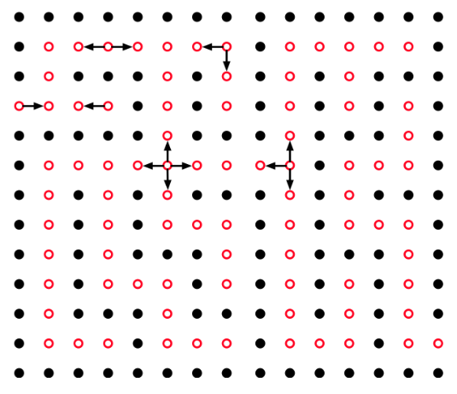

From Maze to Graph

From Maze to Graph
Mazes drawn on paper can be translated into graphs. Each open cell of the maze corresponds to a vertex in the graph, and each adjacency relation between two cells corresponds to an edge. This representation allows us to use graphs to think about maze solving.
For now, think of this graph simply as a way to show connections. Later, we will introduce a search algorithm that can move through the graph to find a path from the start cell to the target cell. In the next steps, we will just look at how the maze can be represented as a graph and how a path can be highlighted.
We will use the following maze, which has a solution, to create a graph.
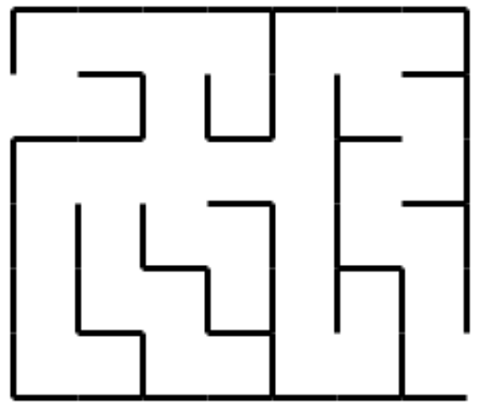

One way to solve a maze programmatically is to use a graph to represent its paths and then find a simple path that connects the vertices representing the start and target cells. To do this, we begin by identifying the open cells of the maze, as shown in the following figure.
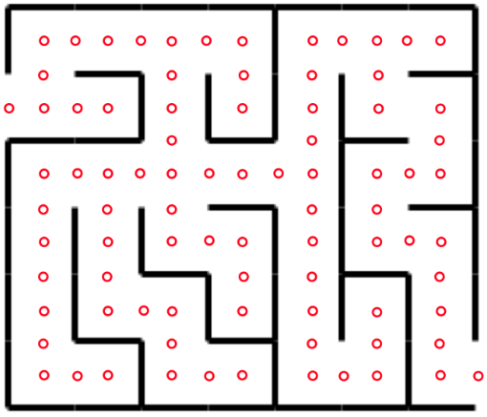

We can then capture the is-adjacent-to relation in graph form. The next figure shows the graph of adjacency relations.

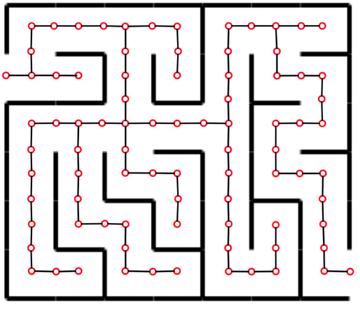

Now let’s focus only on the adjacency graph itself, which contains all the information needed to solve the maze:

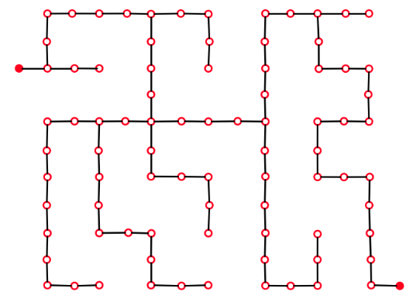

Finally, using this graph, we can highlight one path that connects the start and the target nodes:

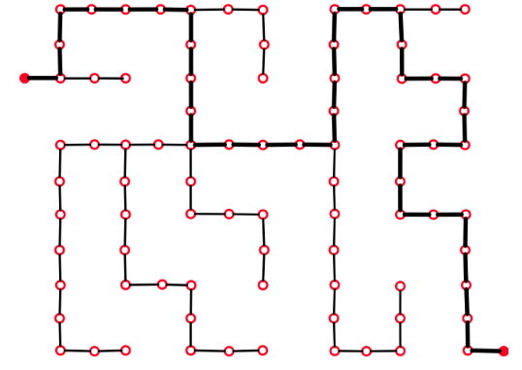

For this project, you will not explicitly create a graph to solve the maze. Instead, you will use the adjacency information of the maze to traverse its graph implicitly. More on this later.

From Maze Drawing to Program Input

From Maze Drawing to Program Input
Before we continue, let’s look at the maze from above and see how easily it converts into a zeros-and-ones format, which is more suitable for being read by a program.
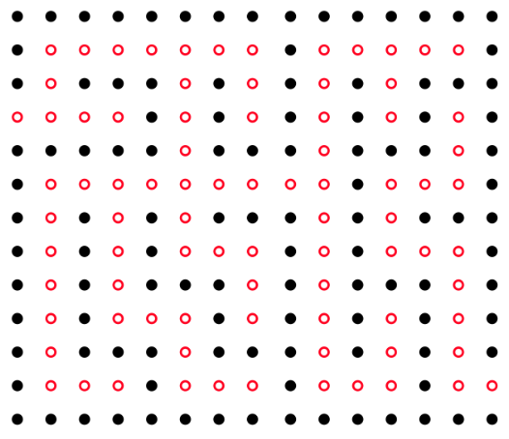

Here the open cells are shown as dots and the walls are solid. Translating this into numbers, we will use zeros to represent the open cells and ones to represent the walls:

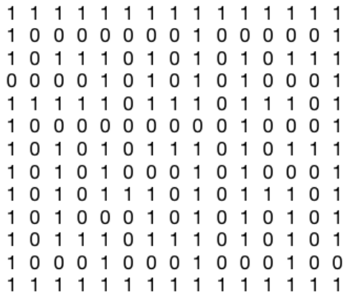

This representation matches the style of the input files that your program will read.

A Backtracking Algorithm

A Backtracking Algorithm
A backtracking algorithm is a method of searching for a path from the start cell to the target cell. The process starts at a particular point (the start cell in the maze) and requires moving from one state to the next by applying a simple rule: continue until either we reach the target cell (in which case the algorithm stops) or we reach a dead end (in which case we backtrack). Backtracking means we take one or more steps backward until we get to a point where another unexplored option is available, then try that path.
For example, in the maze below, we started at the cell represented by the filled red circle with the intention of reaching the other red-filled circle. We took three steps (one at a time) and reached a dead end. We then have to backtrack twice (one at a time) until we return to the blue-filled cell, where there is another option to move forward. Having backtracked to it, we then take the open cell above it.
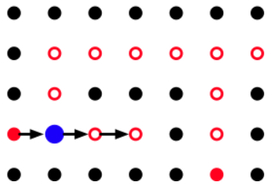

When we choose an adjacent cell to move into, there is no guarantee that the selected cell will lead to the target. At the moment of choice, any unexplored option is as good as the others. Unless we try it, we cannot know whether it leads to the solution. Therefore, when we are at a cell that has multiple adjacent cells, we select one and move into it. If that choice does not lead to the target, we return and try another option.
Here is a backtracking algorithm that works for problems of this nature:
Push the start cell onto the stack
While the stack is not empty do
If the top cell has no unexplored adjacent cell then
Pop the stack
Else
Choose one unexplored adjacent cell
Push that cell onto the stack
Mark it as explored
If this cell is the target then
Exit the loop
End If
End While

If the stack is empty then
No path exists from the start cell to the target cell
Else
The stack now contains the path, in reverse order

Input and Output

Input and Output
- Input: A text file containing the maze as a grid of zeros (paths) and ones (walls). The maze is surrounded by walls, except for two open cells representing the start and target points. There are no spaces between digits. You will need to identify the start and target cells after reading the file.
- Output: The maze printed in the same format as the input, except that zeros on the solution path are replaced by blank spaces. If no path exists, the program should output a message stating that no solution is possible.
Optionally, instead of blanks, you may choose to mark the path with a special symbol such as *, and you can display it in color using ANSI escape sequences supported by most terminals. For example:
"\033[31m*\033[0m" // Red asterisk

Common color codes include:
"\033[31mRed \033[0m"
"\033[32mGreen \033[0m"
"\033[33mYellow\033[0m"
"\033[34mBlue \033[0m"
"\033[35mMagenta\033[0m"
"\033[36mCyan \033[0m"

Here is an example in C++ that prints the word "Blue" in blue by concatenating the start escape sequence, the text, and the reset sequence separately:
#include <iostream>
using namespace std;

int main() {
cout << "\033[34m" << "Blue" << "\033[0m" << endl;
return 0;
}

Example output of a solved maze:
Placeholder: mazeSolvedZeroOne.png

Where to Start

Where to Start
Begin with a design. Identify the data structures you need (for example, a 2D vector for the maze, a stack for backtracking, and possibly a class to represent the maze).
- First, write a simple version that just reads the maze from a file and prints it back exactly as it is. This confirms your file reading works.
- Since each line of the input is a long sequence of digits, read each line as a string and then traverse the string character by character to convert it into integer elements of your 2D array or vector.
- You may assume that the input file is correct, meaning all lines have the same number of zeros and ones.
- Once input and output are correct, add functionality step by step: locate and mark the start and target cells, explore moves, and then implement the backtracking algorithm.
- As your program grows, keep your code modular. Place maze operations inside a class (e.g., Maze) that can store the grid, provide access to cells, and solve the maze.

What to Turn In

What to Turn In
Submit a single zip file of your entire project directory through Canvas. You may choose any project name you like. However, you must carefully follow the instructions provided in the course syllabus under "Programming Projects." In particular, your submission must include the required README file with the specified content. The README is essential for grading, so be sure to provide it exactly as described in the syllabus.

How We Test Your Solution

How We Test Your Solution
On the Blue system, your project will be tested using the following commands. The program must print its results to the terminal (standard output).
unzip NameOfProject.zip
cd NameOfProject
g++ -std=c++20 *.cpp
./a.out name-of-an-input-file

Github
Absolutely—here’s a compact, copy-ready Git cheat sheet tailored to your workflow (SSH + CLion + solo dev). Save it as GIT_CHEATSHEET.md if you like.

New machine (one-time)
# identify yourself
git config --global user.name "Will Meyer"
git config --global user.email "willmeyer2150@gmail.com"
git config --global pull.rebase true # avoids merge bubbles
git config --global init.defaultBranch main

Start a repo from an existing folder
cd /path/to/CS315_Will_Meyer_Solving_A_Maze_Project
git init -b main
# create .gitignore (already done for you)
git add .
git commit -m "Initial commit"
# connect to GitHub (SSH)
git remote add origin git@github.com:willmeyer2150/CS315_Will_Meyer_Solving_A_Maze_Project.git
git push -u origin main

Start by cloning an empty repo (already created on GitHub)
cd /path/for/projects
git clone git@github.com:willmeyer2150/CS315_Will_Meyer_Solving_A_Maze_Project.git
cd CS315_Will_Meyer_Solving_A_Maze_Project
# drop files in, then:
git add .
git commit -m "Initial commit"
git push

Daily flow (feature branches + PRs or just push main)
git status # see changes
git checkout -b feat/short-desc # new branch for a unit of work
# ...edit files...
git add <files> # stage changes
git commit -m 'feat: concise message'
git push -u origin feat/short-desc # first push sets upstream
# (open PR on GitHub, merge, then:)
git checkout main
git pull # rebase by default (see config above)

Quick updates on main (no branches)
git add -A
git commit -m 'feat: <what you did>'
git push

Inspect & review
git status
git diff # unstaged changes
git diff --staged # what will be committed
git log --oneline --graph --decorate --all -n 15

Fixups & “oops” situations
# forgot a file:
git add <file>
git commit --amend # edit last commit (keeps message)

# undo unstaged edits (to last commit):
git restore <file>

# unstage but keep file changes:
git restore --staged <file>

# revert a bad commit that’s already pushed (safe):
git revert <commit-sha>

# move branch pointer (be cautious):
git reset --soft HEAD~1 # keep changes staged
git reset --mixed HEAD~1 # keep changes, unstaged (default)
git reset --hard HEAD~1 # DROP changes (danger)

Work in progress stash
git stash push -m "wip: thing"
git stash list
git stash pop

Remotes
git remote -v
git remote set-url origin git@github.com:<user>/<repo>.git
git fetch --all

.gitignore hygiene
# after adding a new ignore pattern, stop tracking an already committed file/dir:
git rm -r --cached cmake-build-debug
echo "cmake-build-*/" >> .gitignore
git add .gitignore
git commit -m "chore: ignore build outputs"

Tags (optional, for milestones)
git tag v0.1
git push origin v0.1

Resolve a merge conflict (fast recipe)
git pull # or: git pull --rebase
# if conflicts appear:
# 1) open files, fix markers <<<<<<< ======= >>>>>>>
git add <fixed-files>
git rebase --continue # if rebasing
# or:
git commit # if merging
git push

Rename current branch to main (if needed)
git branch -m main
git push -u origin main
git push origin --delete master # only if master existed remotely

Common CLion tips
- Working directory: Run → Edit Configurations → Working directory → $ProjectFileDir$
.gitignore should include:
cmake-build-*/
build/
.idea/
.DS_Store
CMakeFiles/
CMakeCache.txt
*.o *.obj *.a *.so *.dylib *.exe *.out *.log
*.profraw

Commit message pattern (keep it short)
feat: implement BFS pathfinding
fix: handle empty lines in maze parser
refactor: split solver into Graph and Search
docs: add build & run instructions to README
test: add 13x15 maze fixture
chore: update .gitignore

Shell gotcha with !
macOS zsh may treat ! specially inside double quotes. Use single quotes:
git commit -m 'feat: works!'
# or escape: "feat: works\!"

If you want, I can drop this into a GIT_CHEATSHEET.md in your repo via the exact Git commands, but you’re already set to fly solo with this.

